

Learn from the Past:
What Hurricane Irma Taught Us About Preparedness

Three years ago, Hurricane Irma barreled down on Florida, causing 7 million evacuations, 129 deaths and $50 billion in damage, per the Centers for Disease Control and the National Oceanic and Atmospheric Administration (NOAA). During Florida Preparedness Month, and the anniversary of one of the costliest and most severe storms in Florida’s history, is the time to reflect on lessons learned and to increase preparedness for future storms.

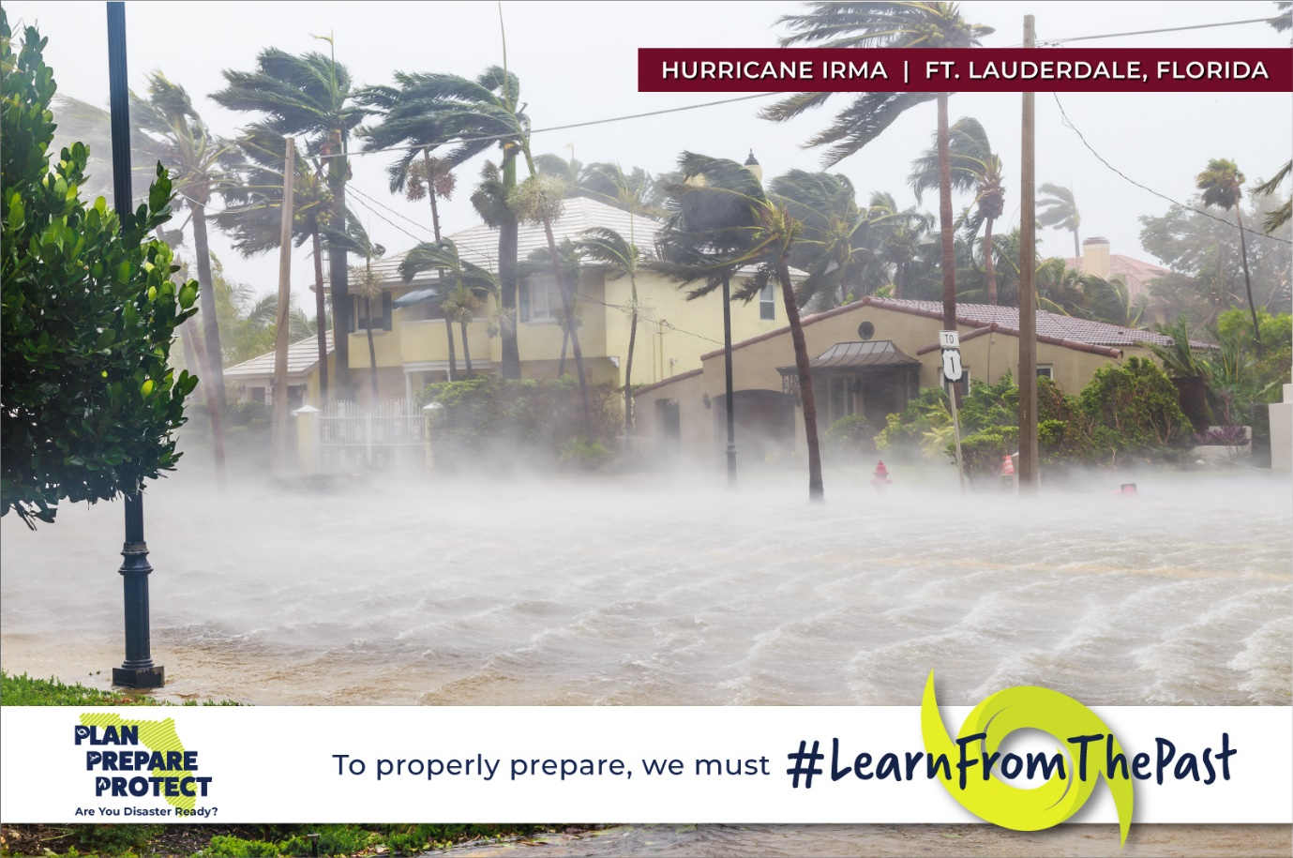

Before the Warnings

The time to start planning is before the storm. Review your insurance policy to ensure you have adequate coverage to repair or replace your home, possessions and structures. Proper insurance coverage can decrease the financial burden of storm recovery. Change your insurance policy now, if needed, as many insurance companies stop issuing polices and updates when a tropical storm or hurricane watch or warning is issued.

  
  Create a home inventory: photograph or video your home and contents. Note serial numbers and models; gather receipts. A home inventory will assist the insurance adjuster to accurately determine the amount for repairs or replacement.

According to NOAA, Hurricane Irma’s highest wind speed was 142 mph. Conduct an analysis of risks and mitigate damage that’s caused by water intrusion or flying objects: trim trees; purchase storm shutters for windows and doors; and remove debris from gutters to direct water from your home.

Heed Warnings

Floridians can experience ‘hurricane fatigue’ and a lack of preparation when constantly hearing about the threat of storms. In actuality, about 40% of hurricanes in the U.S. strike Florida, equivalent to 2 in every 5 hurricanes, per NOAA. It’s imperative that you take heed to hurricane watches or warnings.

  The first Hurricane Irma watch was issued September 7th, three days before the storm hit Florida. Three days leading up to a storm are integral in preparing. Take steps to minimize damage - tie down or remove any free-standing fixtures around your home.
  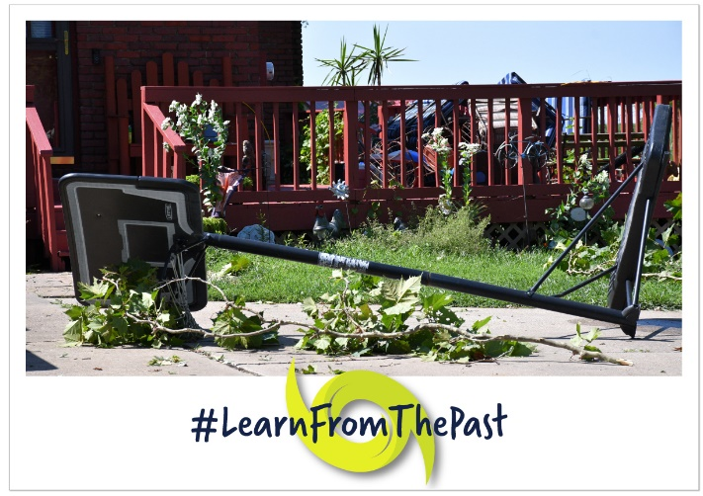

Gather insurance, financial and medical documentation, including your home inventory in case you have to evacuate.

Most importantly, adhere to local officials’ advice regarding evacuations and sheltering to stay safe.

After the Storm

Following the storm, take practical steps to aid in a smooth recovery.

Make emergency repairs to avoid further damage or injury. File your insurance claim as soon as possible to start the claims process and reduce the risk of more damage. Have your home inventory available for the insurance adjuster.

Approximately three-quarters of consumers in South Florida lost power, many for close to an entire week, as a result of Hurricane Irma, per NOAA. One unexpected result of a power outage is that your perishable food may spoil. Some homeowners insurance policies include coverage for spoiled food. Let your insurance agent know you have spoiled items; take photos or video before discarding food.

I implore you to learn from the preparedness lessons Hurricane Irma taught us three years ago. Plan Prepare Protect, Florida!

For help preparing, visit 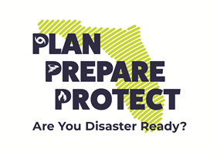www.MyFloridaCFO.com/Division/ICA/PlanPrepareProtect.

www.MyFloridaCFO.com/Division/ICA

Follow me on Facebook and Twitter: @YourFLVoice

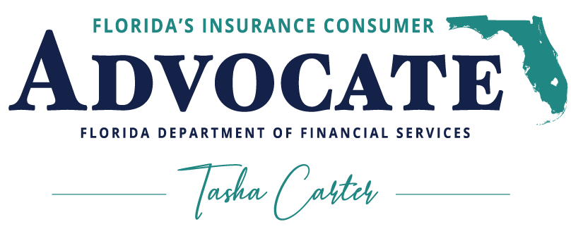

Office of the Insurance Consumer Advocate
Florida Department of Financial Services
200 East Gaines Street, Tallahassee, Florida 32399
YourFLVoice@MyFloridaCFO.com

